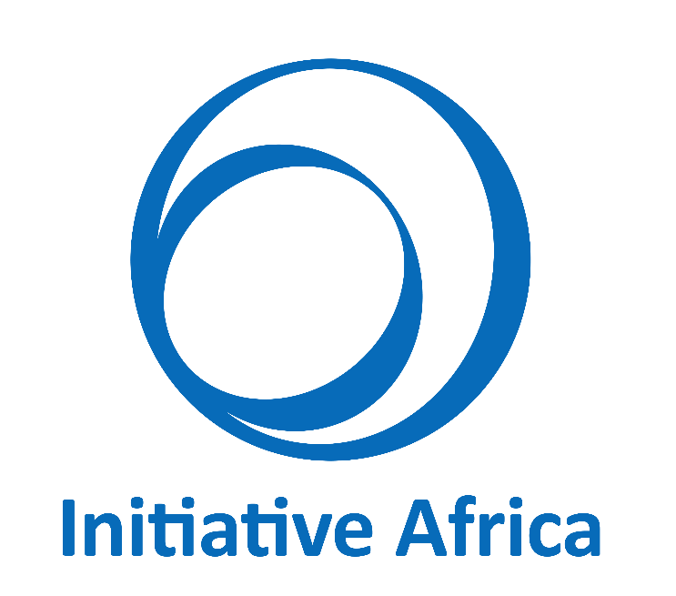

TERMS OF REFERENCE

SHORT TERM INDIVIDUAL CONSULTANCY

Initiative Africa (IA) works to promote self-reliance, opportunity, and access to key supports for persons vulnerable to poverty. Over the past years, IA has teamed up with NGOs, professional associations, policymakers, and media experts to reduce poverty through capacity development and community empowerment.
As we work with our partners to achieve our key objectives that of reducing, alleviating and preventing poverty, we continue to be committed to taking an integrated and coordinated approach with gender issues a part of nearly every IA program decision

Aug 2019
IA/MCH/TOR/SVI/02/19

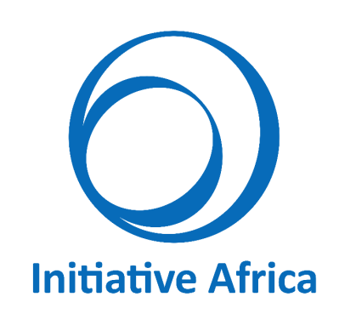

SHORT TERM INDIVIDUAL CONSULTANCY
TERMS OF REFERENCE

- Introduction
Today, it is quite common to find news related to school violence. Unfortunately, most of the people just listen and prefer to ignore such news. They even don’t want to know how this problem is getting bad to worse day by day. But ignorance is not a solution for any problem.
In 2016, Initiative Africa in collaboration with the Ethiopian Teachers Associations developed a school violence measurement tool called the School Violence Index (SVI).
The objective of SVI is to enable schools to ‘measure’ (assess) and discuss the level of violence, with a focus on capacities, progress, performance and joint learning, with the goal to:
- Build understanding of the complex issues involved in school violence;
- Determine strengths and weaknesses of the school soft and hard instruments used to fighting violence;
- Recommend ways to improve the current deficiencies in the form of an action plan.
It was tested in 32 schools and found to be an important tool that serves its purpose. During the tests IA has learnt and tried to include comments provided by the users (education experts, teachers, school principals, students and parents). Nonetheless, IA wishes to join hands with a university to support its effort to eliminate school violence with revising and standardizing the existing SVI Manual.
- About Initiative Africa
Initiative Africa is (IA) a Non-Governmental Organization established in 2002 that promotes Quality Education for all in all the regional states of Ethiopia through teachers’ professional development, research and outreach. It is actively working with public and private sector; partners with some local and international universities to address issues pertinent to quality education, youth development and gender issues.
IA’s key program areas include arts for social development, women and girls empowerment and increasing youth engagement in community development. Currently, IA has started implementing a project titled Gender Equality: Making Change Happen, which focuses on gender mainstreaming and reducing gender-based violence in schools.

- The School Violence Index
Currently, the SVI focuses on the following four school level violence reduction dimensions that are considered to be important:
- School Violence Prevention & Reduction Program: This describes the instruments and mechanisms in place and in use in the school to prevent and/or reduce school based violence. It focuses on developing structured school activities for educating the school community on the school’s rules and policies and giving them the skills to intervene consistently and appropriately.
- School Physical Security Improvement: It refers to the entire school infrastructure including the facilities, fencing and the compound. It also includes the establishment of a regular check (assessment) system that covers the surround area of the school (including students’ routes to and from school) and reports incidences.
- School Policies & Rules to Combat Violence: This refers to the school’s annual plan and actions to have a violence free school environment. It includes the engagement and participation level of all school community members in maintaining the policies and regulations for preventive measures that address any kind of school violence.
- Handling School Violence Incidences: This refers to the process and approaches to handling school violence incidences. It focuses on the practical activities performed by the school after the violent incident happened.
Following the testing of the SVI, IA has determined an updated version of the SVI should be produced. This project is basically to develop and test the revised version of the SVI.

- Scope of Work
The overall objective of the assignment is to review the comments generated by IA when testing the SVI and to shape/propose new amendments that could be used to effectively assess the status of a school regarding school based violence so as to achieve violence free schools.
IA requires the following services from the Consultant:
- Policy and Procedure Expertise: The service provider would initiate the project by receiving an intense understanding of the organization needs with regards to the current SVI version. The service provider will have to conduct a gap analyses from existing policy manual, identify areas of concerns, provide revised / proposed changes, communicate and receive approval;
- Once approved and well communicated the consultant will submit implementation and roll-out plan and participate in the conduct of tests.

- Deliverables
The key deliverables from the project are: an effective, accessible, comprehensible and well-designed SVI version II in Amharic and in English.
Basically the consultant team has to review, amend, revise, re-design and develop the SVI version II including
  - The working documentation related to the SVI provided by IA
  - Review and comment the old policies/procedures in line with the proposed ones and comment about the developments that need to be done.
  - Present IA staff.
  - Develop a role out plan.
  - Completion of the SVI version II manual.

- Institutional Arrangement
IA will;
  - Provide the consultant with relevant documents,
  - Provide the consultant with full support in any review of outputs and conduct of activities,
  - Give feedback to the draft, final reports and all other deliverables prepared by the consultant.
  - Facilitate and organize Meetings/workshops.
All documents and data provided to the consultant are confidential and cannot be used for any other purposes or shared with a third party without any written approval from IA.
- Plan of Work
Total time allocated for the assignment is six (06) weeks. There are three interim deadlines:
- Inception report based on initial facts finding 1 week from the award date
- Draft SVI version II for validation workshop 2 week from the award date
- Completion of the manual as per the comment from the validation workshop and testing 4 week from the award date.
- Interim Report on proposed edition 6 week from the award date

- Required Expertise
The qualification of the consultant required to successfully carry out the exercise is:
- MA Degree in development studies, operation research, social research, Statistics or related fields
- Experience in research on topics related to gender mainstreaming, gender in development projects & policies and violence reduction
- Advanced experience being in a leading role for quantitative and qualitative research & assessment in the above fields and proven experience in the research processes, comprising the design, planning, data collection, data analysis and writing up of results
- Strong quantitative, research, and data analytic skills, including demonstrated knowledge of and experience working with data analysis software such as STATA, R, CS pro and/or similar software’s
- A good appreciation of gender analysis methods and tools for mainstreaming gender in poverty reduction programs and policies
- Proven experience and understanding of gender and development issues in Ethiopia
- Good action, learning research and writing skills

- Timing and Duration
The Assignment is expected to take place for duration of six weeks starting from the award date.
During this period the assessment should follow the work plan and timetable as stated in clause (vII)

How to Apply:
Technical and Financial proposals should be submitted to Initiative Africa Office in person or email to abenezer.t@initiativeafrica.net no later than the deadline stated below.
Deadline for submitting a proposal is on or before 31 August 2019.

